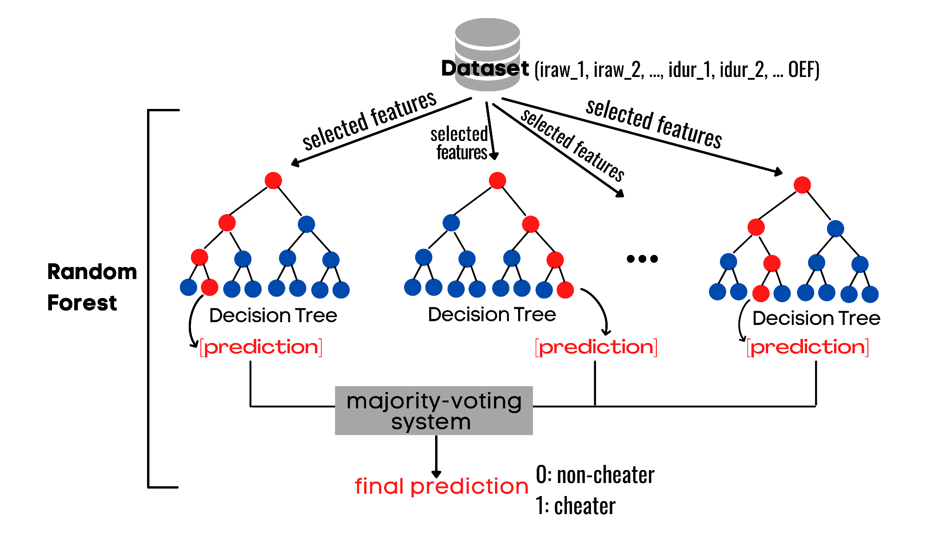

**Figure 1**. Bagging structure.

**Figure 2.** Boosting structure.